A Project Report on

The Future of work:Data Analysis of Glassdoor Jobs

**by**

**K.Jitendra (20AT1A0559)**

**A. Amarnath (20AT1A0506)**

**Shaik Hussain Basha (20AT1A0551)**

**Under the Guidance of**

**MRS.M. JAYA SUNITHA, MTech**

**Associate Professor**



**DEPARTMENT OF ELECTRONICS AND COMMUNICATION ENGINEERING**

**G. PULLAIAH COLLEGE OF ENGINEERING AND TECHNOLOGY**

**(Autonomous)**

(Approved by AICTE | NAAC Accreditation with ‘A’ Grade | Accredited by NBA (ECE, CSE, EEE, CE) |

Permanently Affiliated to JNTUA)

ABSTRACT

In the modern job market, Glassdoor has emerged as a significant platform providing insights into employment opportunities, company cultures, and compensation trends. This study presents a comprehensive data analysis of job listings extracted from Glassdoor, aiming to uncover patterns, trends, and valuable insights to assist job seekers, employers, and researchers in making informed decisions.

The analysis involves a diverse range of industries, job roles, and geographic locations, utilizing advanced data processing techniques to extract, clean, and structure the data. Through exploratory data analysis (EDA), key metrics such as job title frequencies, average salaries, experience requirements, and required skills are examined, shedding light on the current job market landscape.

Furthermore, temporal trends are investigated to identify fluctuations in job listings over time, allowing for a deeper understanding of seasonal demands and economic influences. The study also delves into sentiment analysis, assessing the overall tone of company reviews and their potential impact on job seekers' perceptions.

Incorporating data visualization techniques, this analysis visually represents the findings through graphs, heatmaps, and geographical maps, enhancing the interpretability and communicability of the results. These visualizations provide a snapshot of job market dynamics and assist in identifying emerging job roles and industries.

Ultimately, this data-driven exploration of Glassdoor job listings contributes to a better comprehension of the job market's current state, enabling stakeholders to make well-informed decisions regarding career choices, recruitment strategies, and market trends. The insights presented in this study serve as a valuable resource for individuals seeking employment opportunities and organizations aiming to stay competitive in their talent acquisition endeavors.

**Contents**

**Abstract** 2

**Contents** 3

**CHAPTER 1 INTRODUCTION**  4-5

* 1. Overview 4

1.2Purpose5

**CHAPTER 2 LITERATURE SURVEY**  6-7

2.1 Existing Problem 6

2.2 Proposed Solution 7

**CHAPTER 3 THEORITICAL ANALYSIS** 8

3.1 Block diagram

**CHAPTER 4 RESULT** 9-11

**CHAPTER 5 ADVANTAGES & DISADVANTAGES** 12-13

**CHAPTER 6 APPLICATIONS**  14

**CHAPTER7 CONCLUSION** 15

**CHAPTER8 FUTURE SCOPE** 16

**CHAPTER 1**

**INTRODUCTION**

* 1. **Overview:**

Glassdoor is a well-known online platform that provides insights into companies and jobs. It allows employees and former employees to anonymously share information about their work experiences, company cultures, salaries, interview processes, and more. This information is valuable for job seekers who want to research potential employers and make informed decisions about their career choices.

Glassdoor offers a database of millions of company reviews and ratings, salary reports, and interview reviews, all contributed by individuals who have firsthand experience with these companies. Job seekers can use the platform to gain insights into the work environment, compensation packages, and growth opportunities offered by various companies.

In addition to employee reviews, Glassdoor also offers a job search feature that aggregates job listings from different sources, allowing users to search for and apply to jobs directly through the platform. This combination of company insights and job listings makes Glassdoor a valuable resource for those seeking employment and wanting to learn more about the companies they are considering for their next career move.

In conclusion, Glassdoor is a prominent online platform that provides valuable insights for job seekers and individuals looking to learn more about companies. Through employee reviews, salary reports, and interview experiences, Glassdoor offers a transparent view into company cultures, work environments, compensation packages, and growth opportunities. This information empowers job seekers to make more informed decisions about their career choices and helps them find companies that align with their preferences and goals. Additionally, Glassdoor's job search feature makes it convenient for users to explore and apply for job opportunities directly through the platform. Overall, Glassdoor serves as a bridge between job seekers and employers, fostering a more transparent and informed job market.

* 1. Purpose:

The primary purpose of Glassdoor Jobs is to provide job seekers with comprehensive and transparent insights into companies and job opportunities. It serves several key purposes:

Company Insights: Glassdoor allows current and former employees to share their experiences, providing information on company culture, work-life balance, management styles, and more.

Interview Preparation: The platform offers interview reviews and tips shared by candidates who have gone through the interview process at specific companies. This information helps job seekers prepare for interviews by providing insights into the types of questions asked and the interview format.

Job Listings: Glassdoor aggregates job listings from multiple sources, allowing users to search and apply for jobs directly on the platform. This streamlines the job search process and provides a convenient way for job seekers to connect with potential employers.

Enhanced Decision-Making: By providing detailed information and reviews, Glassdoor enables job seekers to make more informed decisions about their career moves. This reduces the likelihood of entering an unsuitable work environment and increases the chances of finding a fulfilling job.

Transparency and Accountability: Glassdoor encourages companies to maintain transparent and positive work environments, as employee reviews and ratings are publicly visible. This fosters accountability and motivates companies to prioritize employee satisfaction.

Market Research: Glassdoor data is also valuable for businesses and researchers studying employment trends, workplace satisfaction, and industry standards. This data can inform strategies for attracting and retaining talent.

In essence, the purpose of Glassdoor Jobs is to bridge the information gap between job seekers and employers, facilitating better decision-making in the job search process and promoting a more transparent and informed job market.

**CHAPTER 2**

**LITERATURE REVIEW**

* 1. **Existing Problem:**

Data Quality and Consistency: Glassdoor job listings can vary in terms of data quality, completeness, and consistency. Job titles might be phrased differently for similar roles, salary information may not always be accurate, and job descriptions might lack standardization. This inconsistency can hinder accurate analysis and interpretation.

Unstructured Data: Job reviews and company descriptions often contain unstructured text data, making it challenging to extract meaningful insights. Sentiment analysis and natural language processing techniques are required to transform this unstructured data into actionable insights.

Limited Context: Glassdoor data provides information primarily about job listings, salaries, and reviews. However, it may lack contextual information about the broader economic environment, industry trends, and competitive job platforms, which could impact the interpretation of findings.

Data Volume and Scalability: The sheer volume of job listings and reviews on Glassdoor can pose challenges for data processing and storage, particularly when conducting large-scale analyses or attempting to cover multiple industries and locations.

Data Privacy and Ethics: Ensuring the privacy and ethical handling of personal data within job listings and reviews is crucial. Researchers must navigate the ethical implications of using user-generated content and adhere to relevant data privacy regulations.

Geographic and Industry Variation: Different industries and geographic regions may have distinct job market dynamics, salary norms, and cultural factors. Failing to account for these variations can lead to oversimplified or inaccurate conclusions.

Dynamic Nature of Data: Job listings on Glassdoor are continuously updated, making it challenging to capture real-time trends and changes accurately. Frequent updates require analysts to develop strategies for data extraction, transformation, and loading (ETL) to keep their analysis up to date.

Integration with External Data Sources: For a more comprehensive analysis, it may be necessary to integrate Glassdoor data with other external data sources, such as economic indicators, demographic data, or industry-specific metrics. This integration process can introduce additional complexities.

* 1. **Proposed Solution:**

**1. Data Collection:**

Scrape job-related data from Glassdoor using web scraping tools or APIs.

Collect information such as job title, company name, location, salary, job description, ratings, reviews, benefits, and interview experiences.

**2. Data Cleaning and Preprocessing:**

Handle missing values, outliers, and inconsistencies in the data.

Standardize job titles, company names, and locations.

Convert salary information to a common currency and format.

Text processing: Remove stop words, punctuation, and perform stemming/lemmatization.

**3. Exploratory Data Analysis (EDA):**

Visualize the distribution of job titles, industries, locations, and salaries.

Analyze trends in job listings over time.

Explore correlations between job satisfaction, ratings, and benefits.

**4. Sentiment Analysis:**

Perform sentiment analysis on job reviews to gauge employee satisfaction and identify positive/negative sentiments.

Extract keywords and phrases related to employee experiences, work culture, and benefits.

**5. Salary Analysis:**

Calculate average, median, and range of salaries for different job titles and industries.

Compare salaries across locations and experience levels.

Visualize salary distributions and trends.

**6. Company Analysis:**

Analyze company ratings, reviews, and interview experiences.

Identify companies with high employee satisfaction and positive reviews.

Compare company cultures and benefits.

**7. Natural Language Processing (NLP) Techniques:**

Use topic modeling to identify common themes in job descriptions and reviews.

Cluster companies based on employee sentiments and experiences.

Extract insights from text data using techniques like Named Entity Recognition (NER).

**8. Predictive Modeling:**

Build predictive models to estimate salaries based on job title, location, and experience.

Predict job satisfaction or turnover based on various factors.

**9. Interactive Visualization:**

Create interactive dashboards using tools like Tableau, Power BI, or Python libraries (e.g., Plotly, Dash).

Allow users to explore job data, filter by different criteria, and visualize trends.

**CHAPTER 3**

**PROPOSED METHOD**

* 1. **Block Diagram:**

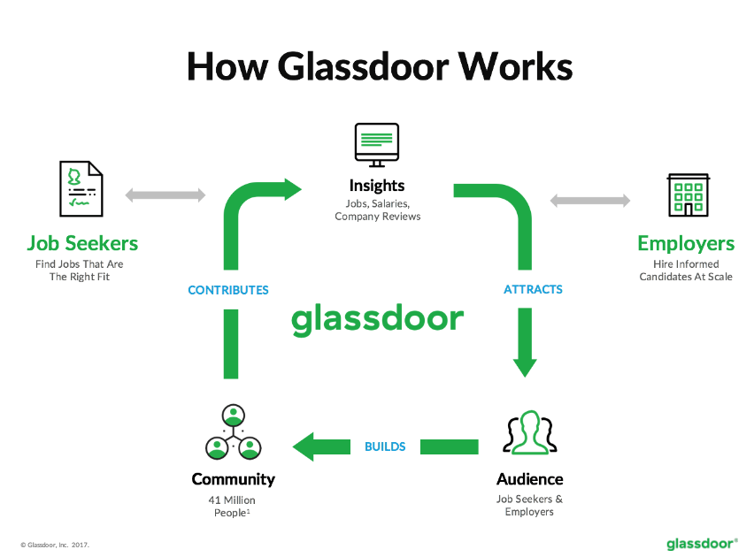

Here are the main ways that employers collect data in a job analysis: Interviews: Asking an employee to give details about their job is one way to create an accurate job description. Employers will ask questions about specific tasks and also request a breakdown of the duties performed by those in a certain position.

**CHAPTER 4**

**RESULTS**

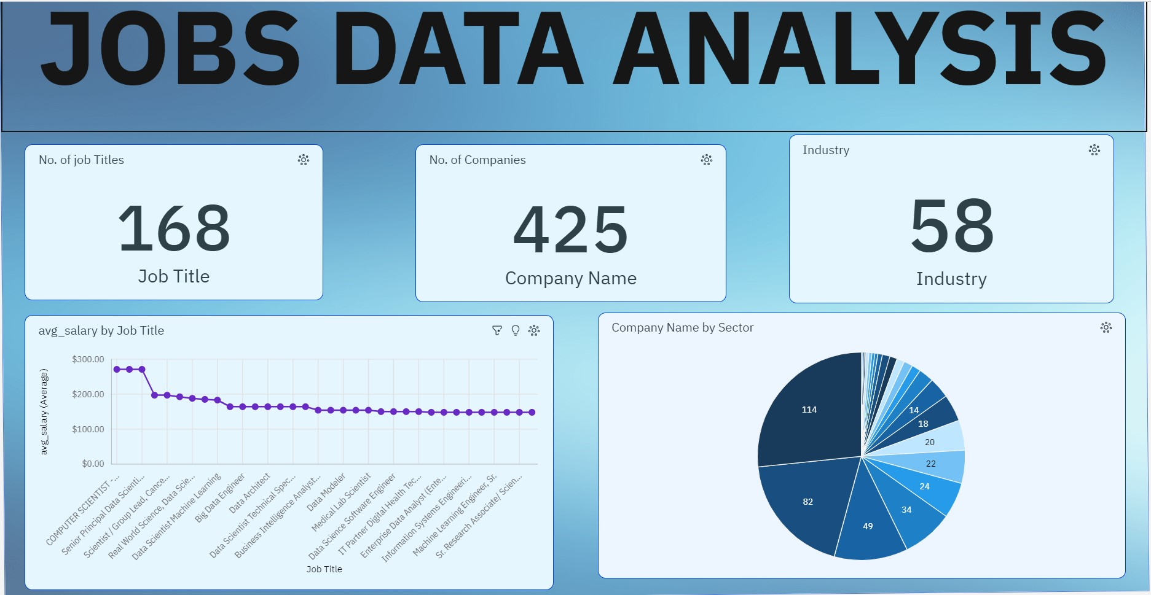

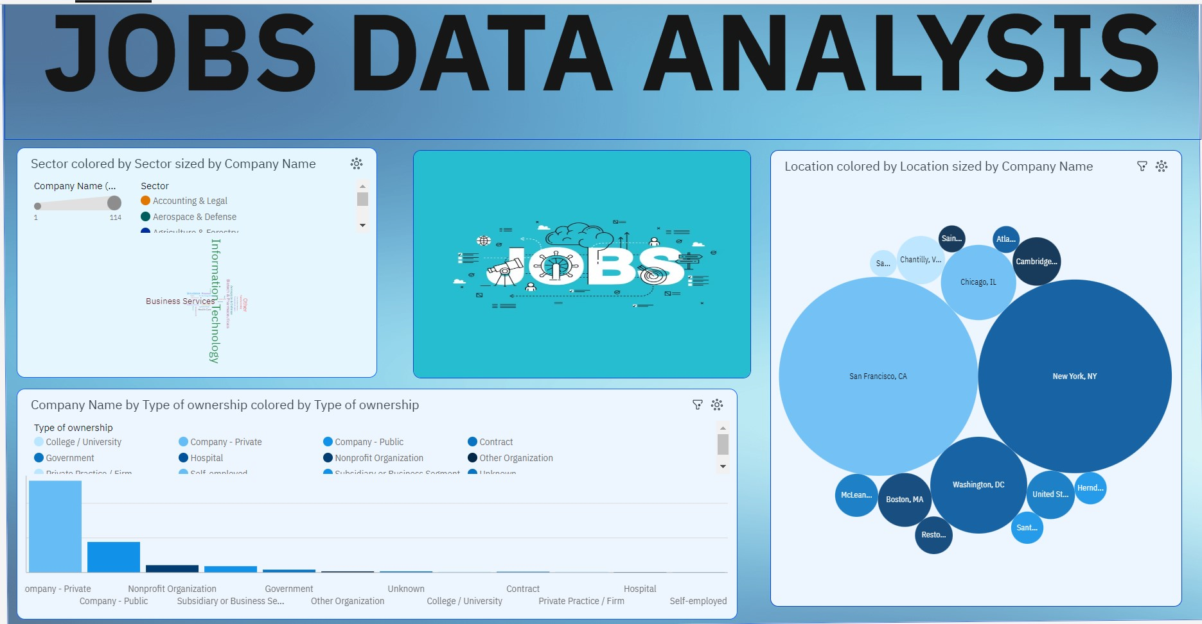

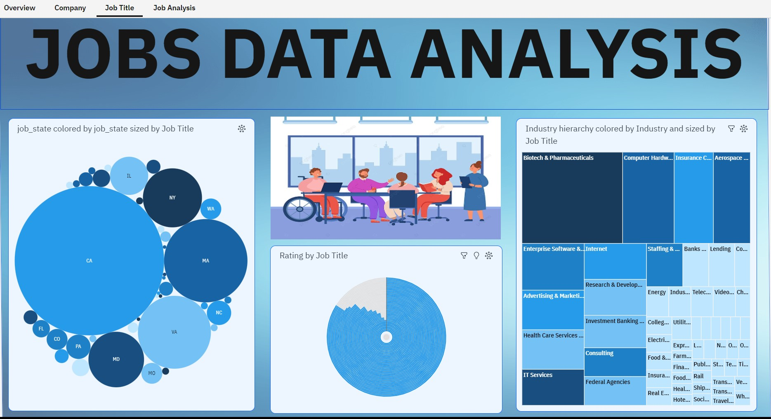

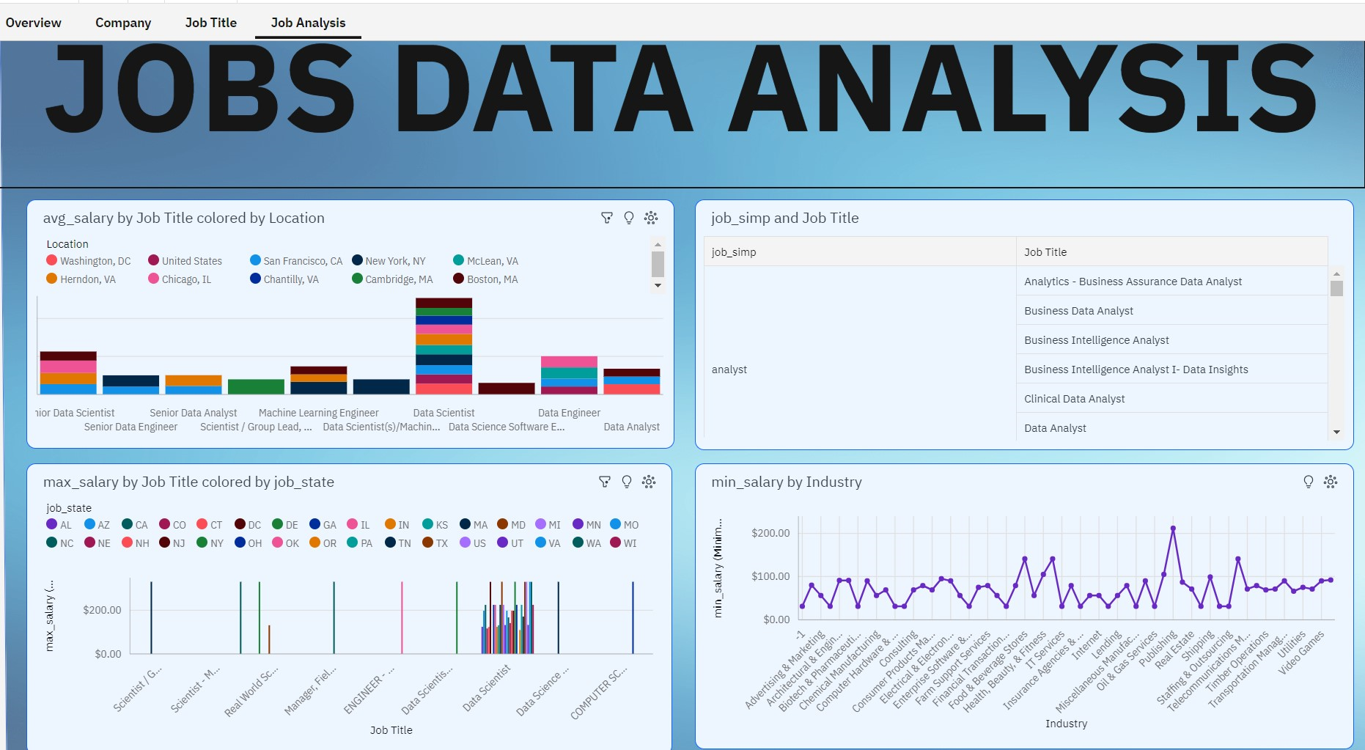0



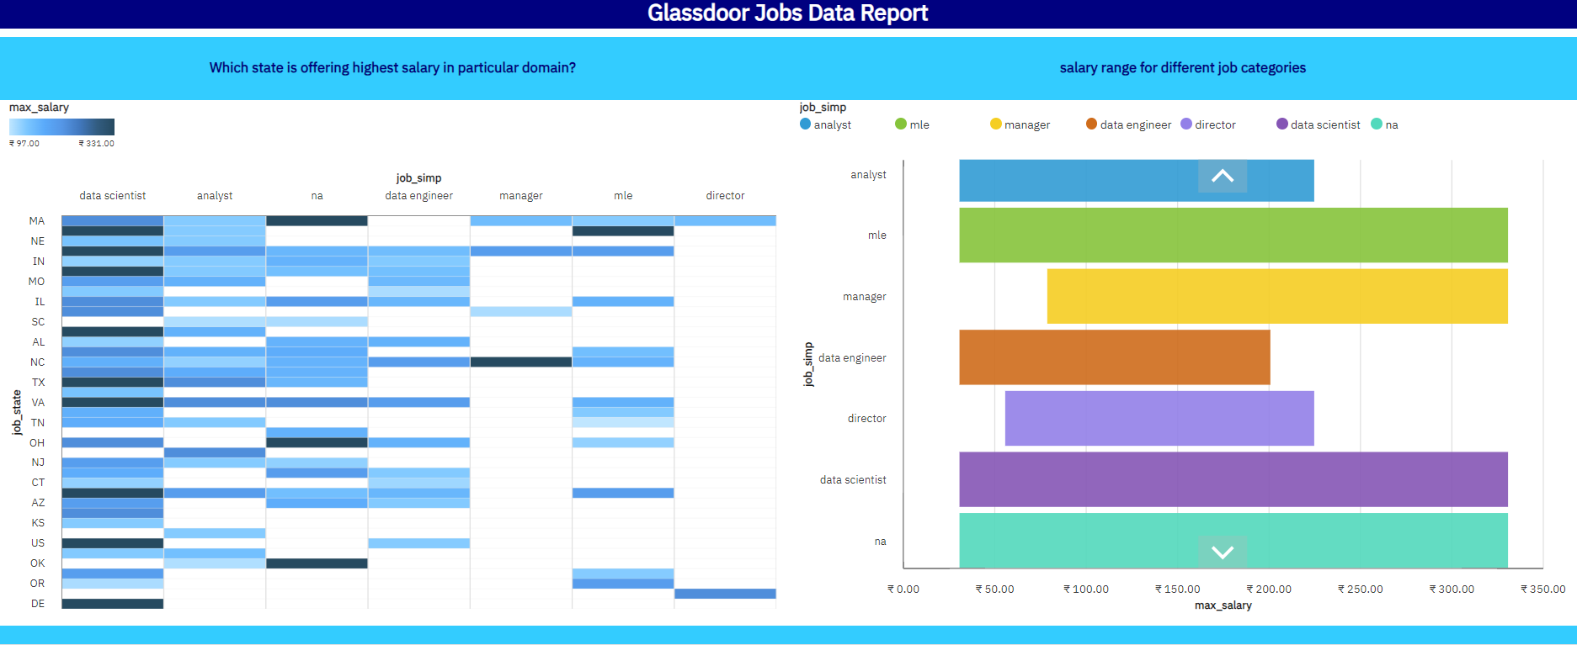

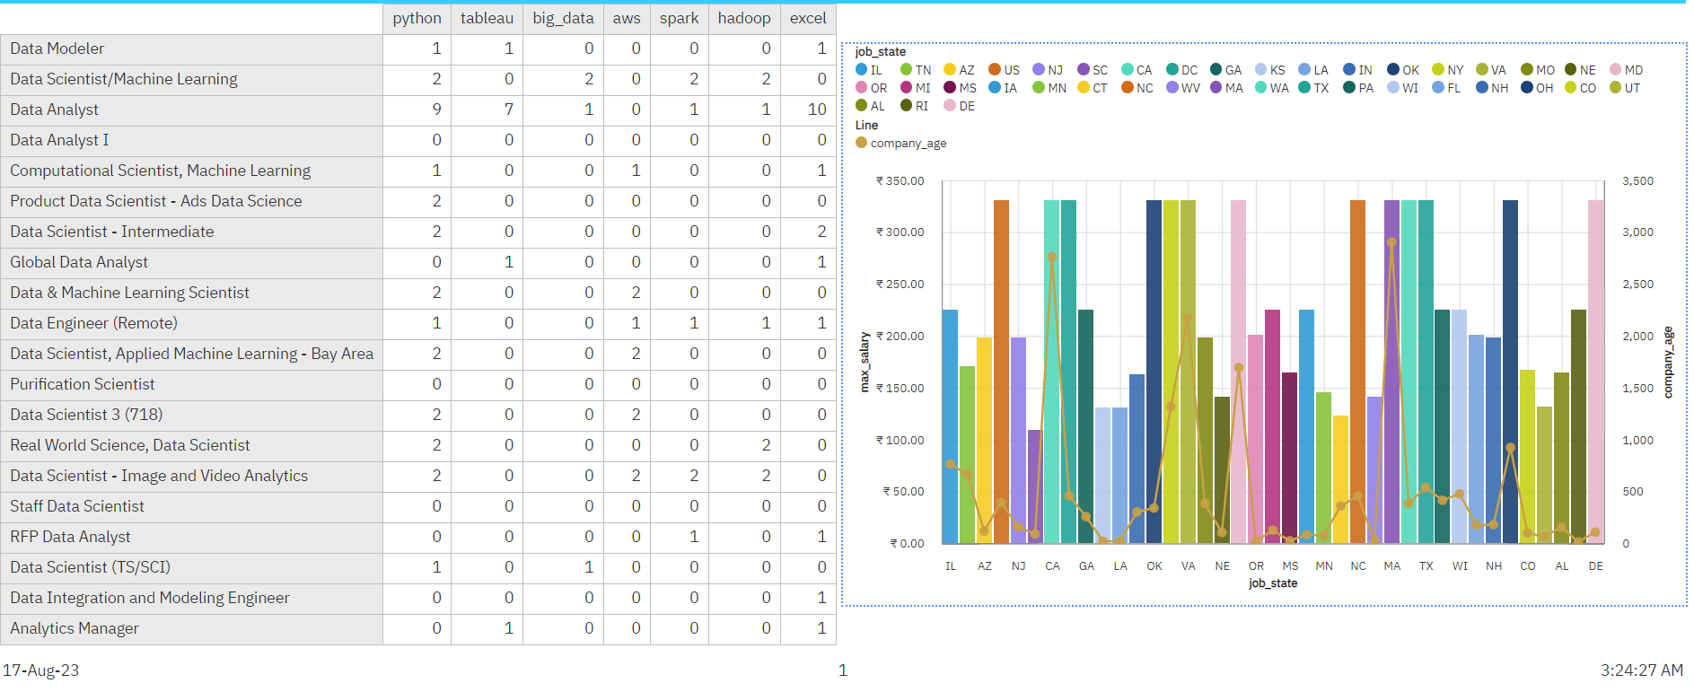

**CHAPTER 5**

**ADVANTAGES & DISADVANTAGES**

# Advantages of Data Analysis of Glassdoor Jobs:

Analyzing data from Glassdoor jobs can provide several advantages for job seekers, employers, and researchers. Glassdoor is a platform where employees and former employees can anonymously review companies and provide insights into various aspects of their work experiences. Here are some advantages of data analysis of Glassdoor jobs:

**Insight into Company Culture:** Glassdoor reviews often contain information about company culture, work environment, management styles, and employee morale. Analyzing this data can help job seekers understand what it's like to work at a particular company and whether it aligns with their values and preferences.

**Salary and Compensation Insights:** Glassdoor reviews often include information about salaries, bonuses, and other compensation details. This data can provide valuable insights into industry-standard pay for different job roles and help job seekers negotiate better compensation packages.

**Job Satisfaction and Employee Experience:** By analyzing employee reviews, you can gain an understanding of overall job satisfaction, employee engagement, and experiences at different companies. This information can help job seekers make informed decisions about potential employers.

**Company Reputation and Brand Perception:** Glassdoor reviews contribute to a company's online reputation and brand perception. Analyzing this data can give employers insights into how they are perceived by current and former employees, which can influence their efforts to improve workplace conditions and attract top talent.

**Identifying Trends and Patterns:** Large-scale data analysis of Glassdoor reviews can reveal trends and patterns in the job market, such as industries with higher job satisfaction, common concerns across different companies, or emerging workplace practices.

**Competitor Analysis:** Employers can use Glassdoor data to analyze their competitors' strengths and weaknesses in terms of employee satisfaction, benefits, and work culture. This information can inform their strategies to attract and retain talent.

**Career Planning:** Job seekers can use Glassdoor data to plan their career paths by understanding the skills, qualifications, and experiences required for different roles. They can also identify companies that offer opportunities for growth and advancement.

However, it's important to note that while Glassdoor reviews can provide valuable insights, they are based on individual experiences and opinions, which might not reflect the entire truth about a company. It's recommended to consider a variety of sources and perspectives when making important career or hiring decisions.Top of Form

**Disadvantages of Video Game Analysis**:

While data analysis of Glassdoor jobs can provide valuable insights, there are also some potential disadvantages and limitations to consider:

**Sample Bias:** Glassdoor reviews are contributed by individuals who choose to share their experiences. This can lead to sample bias, as people who have extreme experiences (either very positive or very negative) might be more motivated to leave reviews. This can skew the overall perception of a company.

**Anonymity and Validation:** Since Glassdoor reviews are often anonymous, there's no way to verify the authenticity of the reviews. Some reviews might be fabricated, exaggerated, or written with specific agendas in mind, which can make it challenging to determine the accuracy of the information.

**Limited Context:** Reviews on Glassdoor might lack context or details about specific situations. A negative review might not provide the full story behind an employee's experience, and a positive review might not cover all aspects of a company's operations.

**Subjective Nature:** Reviews are inherently subjective and reflect the opinions and perceptions of individuals. What one person considers a positive attribute of a company, another might see as a negative aspect. This subjectivity can make it difficult to draw definitive conclusions from the data.

**Company Size and Industry Variation:** The quality of workplace experiences can vary significantly based on company size, industry, location, and other factors. An analysis might not adequately capture these nuances, leading to generalized conclusions that might not apply universally.

**Lack of Longitudinal Data:** Glassdoor reviews provide snapshots of experiences at specific points in time. Changes in company culture, leadership, or policies might not be accurately reflected in the reviews, especially if they occur after the data was collected.

To overcome these disadvantages, it's important to approach Glassdoor data with a critical mindset, considering it as just one of several sources of information about a company.

**CHAPTER 6**

**APPLICATIONS**

Data analysis of Glassdoor jobs holds a wide range of applications that can greatly impact different sectors. One of the foremost applications lies in the realm of talent acquisition and recruitment. Companies can harness the insights from Glassdoor reviews to comprehend how potential employees perceive them. This knowledge empowers organizations to fine-tune their recruitment strategies and bolster their employer branding efforts, ultimately attracting the most qualified candidates who resonate with their values and work culture.

Moreover, the analysis of Glassdoor data directly contributes to elevating employee engagement. By delving into the feedback provided by current and former employees, businesses can pinpoint the factors that drive higher levels of satisfaction and commitment. By addressing concerns and building on positives, organizations can create a work environment that fosters motivation and dedication among their workforce.

The utility of Glassdoor data extends to competitive benchmarking as well. Through careful examination of rankings in areas like compensation, workplace environment, and employee contentment, companies can position themselves strategically within their industry. This competitive edge ensures that the company remains attractive to prospective employees while continuously improving its operations to retain existing ones.

Human resources strategies can also be optimized through Glassdoor data analysis. HR teams can identify recurring patterns and trends in employee feedback, thereby tailoring policies and initiatives that align with employees' expectations. This approach not only enhances the overall work experience but also demonstrates a commitment to addressing employee concerns effectively.

Furthermore, Glassdoor reviews frequently disclose salary and benefits information. Leveraging this data, organizations can ensure that their compensation packages are not only competitive but also commensurate with industry standards. This data-driven approach to remuneration can aid in talent attraction and retention.

Beyond organizational realms, Glassdoor data analysis offers implications for diversity and inclusion initiatives. By gleaning insights into the experiences of employees from diverse backgrounds, companies can develop targeted programs that cultivate an inclusive work culture, ultimately benefiting both the organization and its employees.

CHAPTER 7

CONCLUSION

In conclusion, the data analysis of Glassdoor jobs presents a multifaceted and invaluable resource that extends its influence across various sectors. As organizations and individuals navigate the ever-evolving landscape of employment, the insights gleaned from employee reviews on Glassdoor offer a unique window into workplace cultures, job satisfaction, and the dynamics that shape professional experiences.

This trove of information empowers job seekers to make informed decisions about their career paths, aligning their aspirations with companies that resonate with their values. Simultaneously, businesses can leverage these insights to tailor their recruitment strategies, refine their employer branding, and enhance their employee engagement initiatives.

The applications span beyond the realm of human resources, extending to academia, policy advocacy, and market research, thus impacting broader economic and societal considerations.

However, it is essential to approach these insights with a discerning eye, recognizing the inherent subjectivity of reviews and their potential limitations.

When harnessed judiciously, data analysis of Glassdoor jobs can reshape the contours of workplace environments, foster positive change, and ultimately contribute to a more harmonious and fulfilling world of work for all stakeholders involved.

CHAPTER 8

FUTURE SCOPE

The future scope of data analysis of Glassdoor jobs holds immense promise as technology continues to evolve and reshape the world of work. With advancements in natural language processing, machine learning, and sentiment analysis, the depth and accuracy of insights derived from employee reviews are poised to significantly increase.

The integration of AI-driven algorithms will enable a more nuanced understanding of the sentiments expressed in reviews, allowing for a better differentiation between genuine experiences and potential biases. This will, in turn, offer job seekers a more accurate and comprehensive view of companies and their cultures.

Furthermore, as the gig economy expands and remote work becomes more prevalent, the scope of Glassdoor data analysis will extend beyond traditional organizational boundaries. Freelancers and remote workers can contribute their experiences, providing a broader perspective on companies' remote work policies and practices. This expansion could also facilitate the analysis of trends related to work-life balance, the effectiveness of virtual collaboration, and the challenges faced by remote workers.

In the years ahead, Glassdoor data analysis could evolve to offer predictive insights, guiding job seekers towards companies that align with their preferences and career trajectories. Moreover, organizations will increasingly harness these insights not only to attract talent but also to foster continuous improvement in their work environments.

By actively addressing concerns raised in employee reviews, companies can demonstrate their commitment to their workforce and create an environment conducive to growth and innovation.

The future potential of Glassdoor data analysis extends to fields such as behavioral economics, organizational psychology, and sociological studies. Researchers can delve deeper into deciphering employee motivations, job transitions, and the impact of workplace experiences on overall well-being.

This interdisciplinary approach will contribute to a more holistic understanding of the complex dynamics between employees, employers, and organizational structures.